

***C onciliation: Choosing Better Over Bitter***

Life calls on us to deal with and resolve conflict every day. We find conflict in our workplace, in our communities, in our families and in the organizations to which we belong. Psychologists have long noted that resolving conflict in a manner that includes all participants and creates a shared solution results in the creation of stronger bonds and a more productive and caring environment.

Too often, solutions are addressed via win/lose strategies which many times leave one party feeling disempowered, discouraged, and bitter. Conciliation provides participants with the tools to deal with conflict through the use of critical thinking skills, problem solving, and an awareness of the emotions that jeopardize our ability to perform productively. Conciliation is founded on the assumption that if we really hear and understand both sides of an argument on an intellectual and emotional level we can arrive at a productive and collaborative solution that empowers and encourages all parties.

## Conciliation Is a process that:

* Recognizes that everyone has worth
* Everyone can be expected to share their ideas and talents in service to others
* Helps to work through the emotions such as anger, guilt or loss, that cloud the path to a solution
* Moves conflicted groups to consensus.

## What Is Conciliation Training?

Conciliation trainings are day-long workshops that will help the participant learn or better use important communication skills such as:

* *Active listening* when struggling with conflict
* Creating Open Spaces for critical thinking and reflection
* Identifying and implementing *negotiation skills* that will benefit both individuals and the community on the job, or in groups including neighborhoods, congregations and families
* Demonstrating *confidence and self-appreciation* when confronted with defensiveness negativity.

## Who Can Benefit From Conciliation Training?

* Non-profit organizations serving their communities
* Dispute resolution officers
* Principals, Student Affairs Officers, Diversity Inclusion and Equity Officers in both K-12 and Higher Education settings
* Church leaders and lay volunteers
* Managers and executives
* Labor unions and management leaders seeking a different way to address difficult employment issues
* HR offices seeking to resolve employee conflicts
* Executive coaches
* Any person involved in seeking a way to address difficult conflicts between individuals and/or groups.

## Keys To Success

*R eflection:* Conciliation training focuses groups to hear and appreciate the perspectives of the participants and to find an equitable solution to the conflict.

*E quality:* Everyone brings experience and knowledge to the group. Facilitators do not take sides in a conflict or in differences when they arise. Rather, they remain empathetic and caring for the well being of all participants and focus upon motivating the group to develop outcomes beneficial for all parties.

*E motions:* By identifying and sharing the root emotions and personal struggles which we all bring to the table and which potentially block our ability to hear and to understand each other, we can identify common paths and collaborative strategies to resolve conflicts and move from bitter to better.

## Upon Conclusion Of The Training Participants Will:

* Identify how emotions contributed to or hampered their ability to resolve the conflict
* Recognize how emotions, when faced, provide opportunities to resolve conflicts
* Identify past experiences that have caused frustration and how those experiences contribute to the group’s ability to resolve conflict
* Identify skills and abilities of the group that can be used to address future challenges.

## Participants Will Take Away From This Training:

* How to organize conciliation sessions at work, among colleagues, and among communities such as families and congregations or labor unions
* How to motivate self and others to work together for a shared goal
* How to express personal concerns publicly
* How to seek help and assistance from others
* How to form an agreement that includes multiple parties
* How to maintain that agreement over an extended period of time.

## Conciliation Training Will Also Provide:

* + A live engagement with the process
  + An understanding of a process that permits parties to resolve conflicts by embracing win/win solutions,
  + The opportunity for conflicting parties to assume collective leadership to maintain resilient agreements.

# Members of the LMC Team

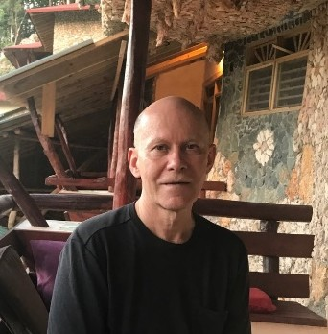

**John Lavin, Ed.D.**

Dr. John Lavin is a teacher from Philadelphia who has worked as English Department Chair at Kensington High School (2006-2017) and as an adjunct professor at Saint Joseph’s University where he also directed the Comey Institute of Labor Relations (1997 – 2005). He coordinated communications for the United Food & Commercial Workers Local 1776 (1989 – 1998) and was Lead Mediator and Director of the Montgomery County Labor Management Committee (2005-2009). His doctoral work was in Educational Leadership. John is fluent in Spanish and has worked with Jesuit organizations in the Dominican Republic, El Salvador, and Colombia.

John received his doctorate from Saint Joseph’s University and completed an M.A. at University College Dublin, Ireland where he specialized in Irish literature and drama. He received his B.A. at Bucknell University.

John was on the advisory board of the Mushroom Workers Union of Kennett Square, PA (1994-2001) as well as serving as Board member for both Transformative Justice Australia (1999-2002) and Saint Joseph’s University’s Faith-Justice Institute (Saint Joseph’s University) (2003-2005). John was President of the Board of Moonstone School & Arts Center (2015) and continues there as Education Advisor.

Currently, John teaches education courses at both Saint Joseph’s University and Rutgers University’s Labor Education Center. He has worked as researcher with the Encyclopedia of British Women Writers; the “Authors in the Prado,” Project in Madrid, Spain; the Federal Mediation & Conciliation Service; as well as the Journal of Individual Employment Rights.

John practices yoga daily and plays jazz percussion in a variety of jazz groups.

**Raheem Curry, Poet, Advocate, Creative Leader**

When I think of Raheem Curry today, I remember Richard Wright who summoned African American History as “the embodiment of a past tragic enough to appease the spiritual hunger of even a [Henry] James …. dense and heavy enough to satisfy even the gloomy broodings of a Hawthorne. And if Poe were alive, he would not have to invent horror; horror would invent him.”

Raheem Curry has not had to invent horror, it has surrounded him. Nonetheless, Raheem has, in his first book of poems, *Infinite Views of a Ghetto Boy*, begun an epic task of developing from history a storytelling craft that will inspire readers to admire the poise in life’s perils and to appreciate the strength of people who have discovered buried in their experiences of loss the ultimate treasure of the courage to hope.

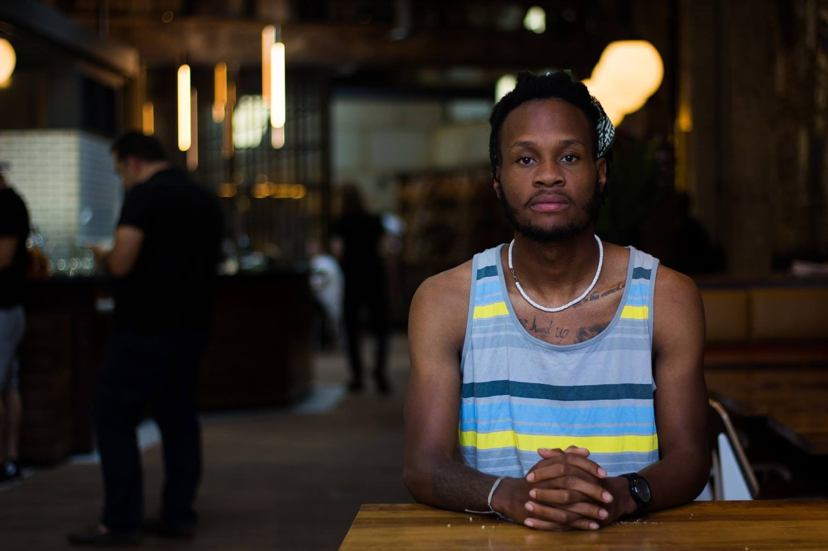

I first met Raheem Curry, not face-to-face in the classroom where I taught him and other 9th graders. I met him in an essay that he submitted on our first day of class detailing the sadness and financial struggle and confusion that his father’s death had caused his family. I read his eulogy at home in the evening of the first day of school. For a child of fourteen years, his writing was thought-tortured. That was extraordinary. That was impactful. He was committed, even then, to his artistry. His pages held so much that he wanted to say about death and life, anger, fear, loss, faith and hope, that I felt very keenly that I wanted to meet this young man. I first met him on the page where he had exorcised the doubt and expelled the depression that he’d been holding down all summer.

The next day as class got started, I located him and handed his writing back to him with comments praising his courageous writing spirit. With his paper, I gave him a fine steel, ballpoint pen with a small digital clock on the handle. I felt I needed to do something to show respect for his profundity. He’d given me a gift on the first day. I wanted to reciprocate on the second day. My note said, “Your father, I’m sure, is very proud of you.”

Then, he wrote. He wrote: Diary accounts, poems, stories, lists, calculations, letters to the living and the dead. But one day, he lost the pen that I’d given him. When he told me of the loss, he shared his fear that the pen had possessed a special magic and that he would no longer be able to write without the pen. When he told me this. I remember rummaging in my desk to find a cheap, plastic pen. The pen I produced was worn and lame but it did spit ink. I gave it to him and said that the magic of all his writing had been in his heart and mind. “Raheem, you are the one who is magical, --not the fancy pen.” He smiled.

Thirteen years later, the poems in the volume that Raheem has anthologized from his life attending college and pursuing his teaching vocation demonstrate the same promise of a creative individual crafting elegant word hoards to resolve life’s rudest challenges. As an inspired student and teacher, he has collected poems that respond to one of Philadelphia’s poorest neighborhoods, Kensington, which is known citywide to be an unrelenting beatdown. In these poems, he is clear about the pain of growing up in a home ravaged by crack addiction. His writing allows him to discern in that brutality the hope that he learned from his mother and father, brothers and sisters as they fought devastating odds to survive.

Indeed, he finds inspiration there.

In his poem, “All The Stars,” Raheem leads his reader to a child’s appreciation of the African American encounter with the horrors of slavery and the primacy of liberation. Writing of himself in the third person, he remembers:

*He imagined the Big Dipper*

*that helped guide Harriet Tubman and many slaves to freedom*

*as a bowl to eat cereal out of.*

With a family fractured by death and poverty, in a neighborhood under constant threat of gun violence, Raheem Curry developed writing capable of addressing emotional demons and of expressing hope.

He recounts the courage that his mother displayed against health struggles and financial reversals. He generously complicates this collection of portraits and vignettes by synchronizing the intimate desires of a young artist’s inner psychological landscape to a cityscape ravaged by homeless wanderers. Looming here are threatening, heavily armed police. Within that scene, he becomes a creative, resourceful observer capable of distinguishing pervasive prejudices against a young Black man from a poor neighborhood. He transcends the police state of the ghetto in writing that refines his understanding and exposes the racism and hate to which he bears witness.

Regardless of the long lists of friends taken by violence and prisons and joblessness, Raheem sustains his vision in a loving spirit that distills his desire to believe in himself and others. It is tough love. Where that toughness will take him is to those stars in which he has envisioned the image of Harriet Tubman finding the way for a child, -ladling out the cereal of liberation with that starry Big Dipper from the sky. It is a celestial trajectory, one from which I have had the honor of learning. Today, I am in the same space with Raheem Curry as I was on the second day of class all those years ago when I scanned the faces of my classroom asking myself, “Which student is Raheem?” These poems demonstrate who Raheem is. They exude the magic that he has improvised from his heart and mind.

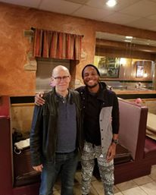

# 

# Jim Castagnera, J.D., Ph.D.

Dr. James (Jim) Castagnera holds an M.A. in Journalism from Kent State University, and a J.D. and Ph.D. (American Studies) from Case Western Reserve University. Jim practiced law for 36 years, before retiring in June 2019: 10 years as a labor, employment and intellectual-property attorney with Saul Ewing Arnstein & Lehr; 3 years as general counsel for Wharton Econometric Forecasting Associates; and 23 years as the associate provost & legal counsel for academic affairs at Rider University.

Currently, Jim devotes his full-time to writing, teaching and training. He is a shareholder and the chief consultant for Holland Media Services, LLC, a freelance writing, training and communications company headquartered in Los Angeles, and a founder of LMC Conflict Training & Conciliation, Inc., a non-profit corporation located in Greater Philadelphia.

Dr. Castagnera’s experience in Alternative Dispute Resolution includes:

* Ten years of service as an arbitrator with the Philadelphia Court of Common Pleas
* Three years of experience as a commercial arbitrator with the American Arbitration Association
* Numerous appearances as an advocate in labor arbitrations, mediations, EEOC Fact-Finding Conferences and other administrative proceedings
* Developer and teacher of a course in “Alternative Dispute Resolution” in Drexel University’s Kline School of Law

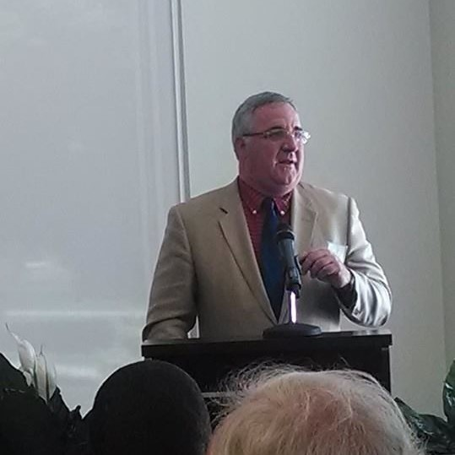

# Tony Campbell, Ph.D.

Dr. Anthony (Tony) Campbell has over 43 years of experience at colleges and universities. For 26 of those years, he served as the Senior Student Affairs officer at Emory & Henry College, Rider University and Saint Xavier University. Additionally, Tony served as the Director of Counseling and Career Planning Center at Hampden Sydney College and the Assistant Director of Counseling and Career Planning at Saint Mary’s College in Notre Dame, Indiana.

Tony has been active both professionally and in the community. He was elected President of the Virginia College Personnel Association, Vice President of the Virginia College Placement Association and was selected to co-chair the annual conference of the Southern College Placement Association.

Tony’s commitment to social justice and community service was recognized by his appointment as a Commissioner on New Jersey Commission for National and Community Service (AmeriCorps) by four different New Jersey Governors from 2000 -2017 and his service as the chair the Chair of the Commission from 2007-2017. Additionally, Tony served as the Chair of the Trenton Public Education Foundation, Treasurer for the Mill Hill Child and Family Development Center in Trenton, New Jersey, Treasurer of the Board for the Mercer County (New Jersey) Addictions Council, and the Chair of the Commission for Young Adult and Campus Ministry for the Diocese of Richmond, Virginia. Active with youth, Tony has mentored many young adults as they progressed from high school through college.

Tony received his Ph.D. In Counselor Education from the University of Virginia; M.Ed. in Counseling and Student Personnel from the University of Georgia; and his B.S. Psychology and Sociology from James Madison University. Tony is married to his wife Melissa and they have 3 children and four grandchildren.